

‘Physiotherapie Dinaj’ Website

SOFTWARE ENGINEERING

Marsia Mustafa

EPOKA UNIVERSITY

FACULTY OF ECONOMICS AND ADMINISTRATIVE SCIENCE

DEPARTMENT OF BUSINESS ADMINISTRATION

BUSINESS INFORMATICS

TIRANA, ALBANIA

May 2024

**‘Physiotherapie Dinaj’ Website**

**Abstract**

This thesis presents the development of a website for a physiotherapy clinic named ‘Physiotherapie Dinaj’. The goal of this project is to create a product that will help the clinic grow further and manage its relationships with the patients. This website is created by using front end and back end technologies such as HTML, CSS, JavaScript, MySQL, PHP, FormSpree, weather information API. The final deliverable product will act as an interface between the staff and the users hoping it will be safe and informative.

**Key words:** website, services, functionality, design, user

**TABLE OF CONTENTS**

**ABSTRACT**…………………………………………………… 2

**TABLE OF CONTENTS**………………………………………3

**LIST OF FIGURES**……………………………………………4

**CHAPTER**

1 Introduction……………………………………………………5

2 Literature review………………………………………………7

3 Methodology…………………………………………………..10

4 Conclusion……………………………………………………..30

5 References………………………………………………………………...31

**LIST OF FIGURES**

**Figure 1**…………………………………………………..10

**Figure 2**…………………………………………………..11

1. **Introduction**

1.1 Background

The project I have been working on for the past two months is a website for a physiotherapy clinic named ‘Physitherapie Dinaj’. This clinic has been operating for the past 10 months in Celle, Germany offering a range of services for its patients. Due to its success in this short period of time, there is a considerable number of new patients that are willing to start their recovery journey at this clinic.

1.2 Problem statement

Due to its short period of time of being in the market, ‘Physiotherapie Dinaj’ still has a small staff to reach out to every new and current patient. Having only one person responsible for the customer relationship section, often causes disarray and dissatisfaction among clients who are unable to access the information they require. Being a clinic that has customer satisfaction as its primary goal, requires a solution for every person included in the process.

1.3 Solution proposed

As the key stakeholders, two of the clinic's owners wanted a digital platform that would welcome and educate potential clients about the clinic's offerings and its dedicated team. The most common solution was to develop a user-friendly website, tailored not only for new users but also for the existing ones. The idea of this project came as a necessity to enhance the experience of incoming patients and provide them with comprehensive information. The target audience seeks for individuals that are keen on understanding the clinic's system, as well as current patients seeking access to personalized online spaces through secure login portals.

1.4 Aim

“To create a user-friendly website which will serve as a centralized hub, showing prospective clients with all information they might require and being there for every question they might have.”

1.5 Main Objectives

* Create a functional website totally dedicated to the clinic
* Provide a user friendly interface that is also understandable for the majority of the users
* Interact with people’s needs and questions that might arise

**2. Literature review**

**2.1 Impact of a good website in the behavioral intention to use of people**

i) General websites

According to the Technology Acceptance Model (TAM), for a user to intend using online information, he should believe that the system serving this type of service will be useful and easy to use. This model was developed by Fred Davis in 1986 and is based on the idea that our attitudes towards technology are shaped by two key factors: perceived usefulness and perceived ease of use. The first element refers to the extent to which we believe that using an online system will enhance our performance or achieve our goals, while the second one refers to users believing that using a technology will be effortless and straightforward. The interaction between these two elements with other external ones is shown in the image below: [1]

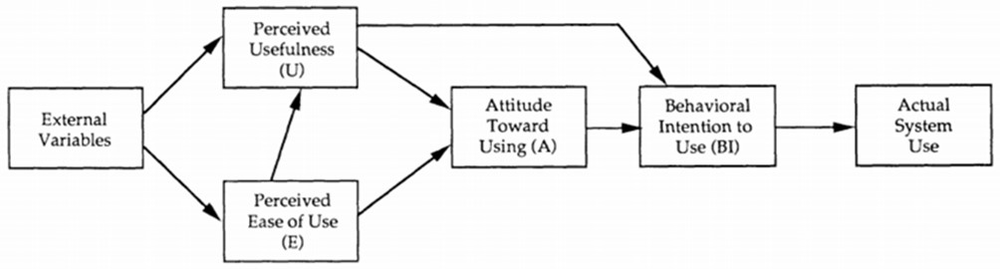

Figure 1 (Illustration of the Technology Acceptance Model (TAM)) [8]

According to TAM, ease of use and perceived usefulness are the most important factors that shape the actual system use. These two factors are affected by external variables.

We can mention as main external factors things like social, cultural and political factors. Social factors include language, social class and skills. Political factors are mainly the impact of using technology in politics and political crises. The attitude toward using a system is concerned with the user’s desirability of employing a particular information system application. While the behavioral intention is more concerned with the likelihood of a person employing the application. [2]

ii) Health website

Other studies have come to a conclusion that the process of deciding whether a good health website should be visited or not is dependent on the perceived quality of the information. They think that the presence of some key elements in such websites can directly affect the approach and attitude of its end users. The schema below shows exactly these key elements:

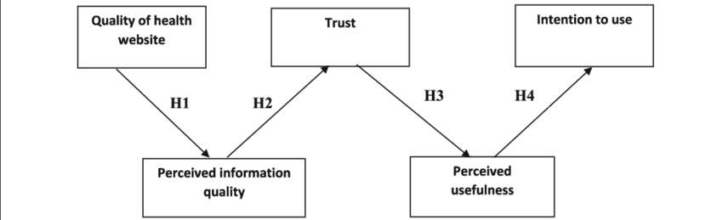

Figure 2 Research framework [9]

In this schema we can directly identify the relationships between the 5 components: ‘Quality of health website’, ‘Perceived information quality’, ‘Trust’, ‘Perceived usefulness’, ‘Intention to use’. The analysts believe that higher levels of perceived information quality are associated with higher levels of initial trust. They identify information quality as an important trust-building mechanism in online interactions and a direct de- terminant of trusting beliefs in exchange relationships. Information that is perceived to be current, accurate, relevant, useful, and complete tends to be more competent, truthful, and credible. [3]

2.2 How does a website help a medical clinic grow

Being available 24/7 to your clients is absolutely helpful but doing it in person is impossible.

The optimal solution is to offer online health information via a website of the clinic. Since it is accessible every time of the day, it provides the perfect interface for clients who are seeking some information about the clinic. This type of customer service impacts directly the people’s trust in the company. [4]

Some studies have stated that around 84% of customers think that businesses that own their personal website are more credible than those with only social media profiles. It is proved that providing comprehensive information about the clinic, its services and any certifications or accreditations can instill trust in visitors. A clear and transparent pricing information for services offered can also help in building trust and reducing uncertainty for some of the potential patients. All of these key elements show potential customers that you are making an effort to extend your healthcare services and provide better accessibility. [4]

2.3 What makes a website credible for the users

According to some research, web design is responsible for 94% of first impressions whether site visitors perceive a website as credible and trustworthy. There are several elements that are part of the list of having a good website. As the most important ones we can mention having: a clear visual hierarchy, having contact information displayed on the footer or other parts of the website and prioritizing intuitive navigation which helps users find what they are looking for quickly and efficiently. [5]

Another key element to keep in mind is having an ‘About’ section that shows a short history and preferably the staff of the clinic. Sharing more about yourself, your team, and your mission always attracts more clients because generally is the first thing users look for in a website.

**3. Methodology**

3.1 Developing model

The development model I have used for this website is the Agile Model. The main reason for choosing this type is the high involvement of the stakeholders in this project. As a clinic that has not been operating for a long time, new requests arise, and changes need to be made almost every week. This type of methodology empowers me as a developer to deliver incremental updates and enhancements iteratively, ensuring that the final product not only meets but exceeds the expectations of the stakeholders. It is a flexible model appropriate for how we thought of developing this website.

3.2 Developing languages

The 'Physitherapie Dinaj' website is a dynamic digital platform crafted using a blend of front-end languages and JavaScript-powered backend functionality.

HTML language has served as a backbone for this website ensuring functionality and user interaction. I have used HTML scripts to create several elements such as: navbar, input boxes, tables, footer, hyperlinks, photos galleries and forms. Each page contains these code scripts which are further designed and used.

To elevate the visual appeal and enhance user experience, I have used the CSS language. Every element created in HTML scripts, is styled and layed out by using CSS code lines. Another key element I have used in the CSS script are the Media Queries to handle the responsiveness of the website for different devices.

I have used the PHP language for the database connection. As mentioned below I have designed three ways of saving data models. One for the ‘Sign up’ form, another for the ‘Login’ form and also for the ‘Contact us’ form. For each of these pages I have developed a PHP script respectively to handle the data submission to the databases.

Finally, the language I have used to develop back-end scripts is JavaScript. Its main function is to design the functional side of the ‘Weather Application’. It contains the API key which connects the website with the ‘OpenWeather’ app for the latest update of weather information. The other key function of the JavaScript in this project is to handle the dynamic side of the website.

3.3 Use case diagram

A use case diagram is a behavioral diagram that illustrates the interaction between the actors and a system. The actor interacts with different specific tasks that are provided for him in the program. The diagram below shows the user as the main actor and the functionalities he can access while navigation through the website.

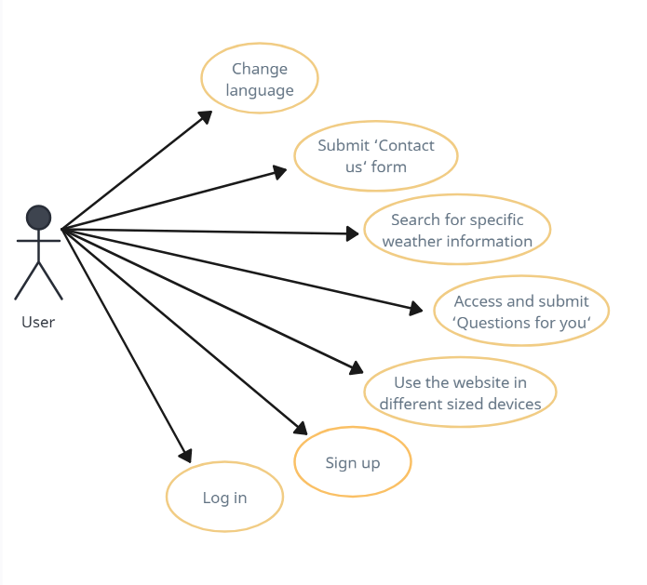

3.4 Sequence diagram

The sequence diagram shows the interaction between the objects of a system and the actor. The diagram below shows a sequence diagram of the sign up page where the user is required to enter their email address and password in order to register as a user. This scheme shows the messages and responses throughout the process.

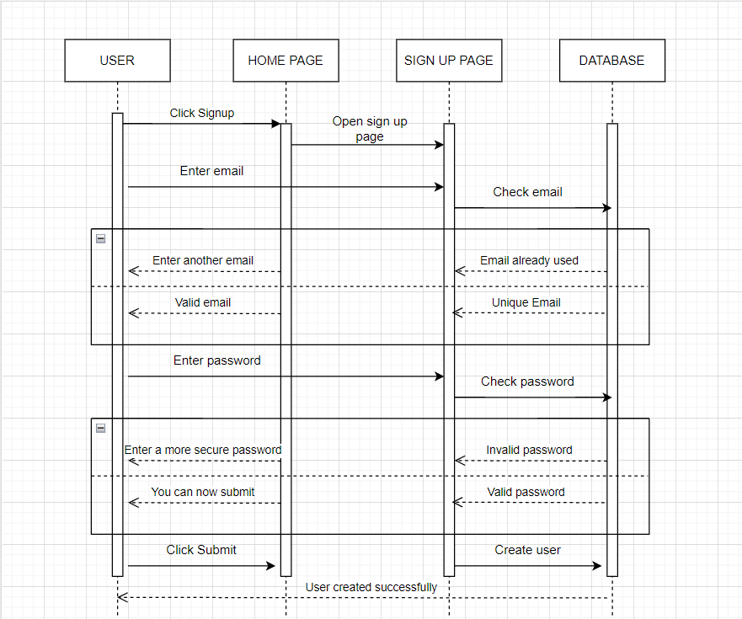

3.5 Database models

For this website I have developed three ways of saving data:

1. The sign up data gathered by patients when they first registered is saved in a database table named ‘signup’ created in PhpMyAdmin. The table has 3 attributes (Name, email, password) that are information that the patients fill in and one Auto Incremented column called ID which serves as a primary key. The key features of this database are:
2. The password is encrypted and saved as a string by using the password hash method
3. The same email can’t be used twice to sign up
4. Patients can only log in after they have primarily signed up
5. All fields are mandatory to be completed by the user

2) The input data users put on their ‘Contact us’ form are saved in Google Sheets in a file named Contact Us. The table has 5 columns that are automatically filled after users input their data on the website.

3) After the patients sign up, they are asked to complete a table that consists of several questions about their health condition. The answers are sent via email using an App called Formspree.

The website can be easily accessed in any web browser by opening the local HTML file called ‘Home’, but for 100% functionality, the website should be opened via Localhost. Since one of the ways of saving data is by storing it into a database in PhpMyAdmin, it is necessary to run the XAMPP program while using LocalHost to run it.

3.6 User requirements

These requirements are the functionality the end users want the final website to have. They are statements written in the natural language of what the system will provide. The user requirements for this website are:

**1.The user should be able to access detailed information about the services the clinic provides**

The primary aim of the website is to provide users with insights into the range of services offered by the clinic. By accessing detailed information about the services provided, users can make informed decisions regarding their healthcare needs. Through a clear presentation of services, users can gain a better understanding of the clinic's treatment offerings, the environment, and the expertise of the staff, enabling them to feel more confident and comfortable in their choice of healthcare provider.

**2.Users should have a form where they can enter their personal data, send the form in order to be contacted by the staff later on**

In inorder to facilitate communication, users are provided with a form where they can input their personal data and request to be contacted by the clinic's staff. This form serves as a bridge between users and the clinic, ensuring that any requests for assistance are promptly addressed. In this way, the website prioritizes user convenience and satisfaction, fostering a positive user experience from initial contact through to engagement with the clinic's services.

**3.Users may choose between two languages while navigating through the website: English and German**

In the navbar of every page, the user can click the german flag for the german language and the american flag for english. Since the clinic operates in Germany and on the other hand most people speak English, I considered these two languages as the most suitable.

**4.Users should be able to create a new account by signing up and have access to their old accounts by logging in**

Users have the capability to create new accounts through a straightforward sign-up process, granting them access to personalized online profiles. By logging in, users can access their accounts and receive the appointments posted by the clinic staff as a pdf file. I think that this feature fosters a user-centric experience.

**5.The navigation process should be smooth with easy accessibility in mind for the end users**

The website prioritizes user-friendliness and easy accessibility to ensure a seamless navigation experience for users. Clear navigation menus and intuitive layout design facilitate effortless exploration of the website's content, allowing users to locate information and services with minimal effort. Additionally, the inclusion of explanatory guides and prompts throughout the site aids users in completing tasks and understanding processes, enhancing usability and reducing friction points in the user journey.

**6. The website should contain a weather app that gives direct data about the weather conditions**

An integrated weather application provides users with real-time weather data, conveniently accessible from the homepage. By inputting their location, users can receive instant updates on weather conditions, enabling them to plan their visits to the clinic accordingly. This feature demonstrates a commitment to user convenience and preparedness, ensuring that users can anticipate and address potential weather-related considerations when scheduling appointments or traveling to the clinic.

**7. There should be a gallery displaying indoor environments of the clinic**

A dedicated gallery showcases indoor environments of the clinic, offering users a visual glimpse into the facilities and ambiance. By featuring authentic images of clinic spaces, users can gain insight into the physical environment and atmosphere of the clinic, fostering transparency and trust. This visual representation allows users to form expectations and familiarize themselves with the clinic's surroundings, contributing to a sense of comfort and reassurance prior to their visit.

By incorporating these user requirements into the website design and functionality, the clinic aims to deliver a user-centric online experience that caters to the diverse needs and preferences of its clientele, fostering engagement, satisfaction, and trust.

3.7 System requirements

Below i have further explained two of the user requirements mentioned above, in the system perspective

**2.1** The system collects every data imputed by the user in the ‘Contact us’ form.

**2.2** The data received from the users input, will be stored and saved automatically in a Google Sheet file named ‘Contact us’ which is a table that has 5 attributes

**4.1** The system collects the information form the Sign up interface imputed by the new patients

**4.2** This data will be stored in a respective table named ‘Sign up’ in a PhpMyAdmin database

**4.3** After signing up, the clients can now complete the ‘Table Form’ and submit it

**4.4** The system will automatically send this table to the clinic’s email

**4.5** The patient can now login in

**4.6** First the system checks if the patient wanting to sign in is already a registered user

**4.7** If yes, the system reads the email entered and checks whether this email has a respective appointment schedule for the patient

**4.8** If yes, the user after login in, can access the schedule in a PDF format and save it for further usage.

3.8 Functional requirements

1. The end-users will be able to create accounts after they register as patients
2. The website will provide detailed information about the physiotherapy services offered,

including types of treatments, specialties, and pricing

1. Provide a clear contact information section, including phone numbers, email addresses,

and a contact form

1. Save the data gathered by the patients into respectively databases
2. Show a weather app that can be accessed by any user

3.9 Non functional requirements

1. User’s login password will be encrypted during storage in the database so the users feel safe and secured to continue navigating
2. The website should be easy to navigate, with intuitive menus and clear calls to action
3. The website should be compatible with popular web browsers
4. Users expect to access immediately into the following pages after signing up or loging in and do not want to encounter any additional steps or delays once they have completed the initial sign-in or sign-up process
5. The web application should be compatible with a range of browsers, devices, and operating systems.

3.10 The web design

Throughout the website, I have tried to use the same design idea for every page that is part of it. The common elements every page has are: a title written in uppercase letters with a different background color, a navigation bar containing all the pages available, a footer with direct links to the Google web services and contact information, a scroll bar and the clickable clinic logo. The website was designed having simplicity and easy navigation in mind. I have tried to use a simple language to be understood by all of the website users.

i) The fonts I have used throughout the website are:

Arial for headings: being one of the most highly readable fonts at various sizes with structured and diagonal strokes. This creates a less computerized look than some other san serif fonts. [6]

Time new Roman for in-page texts: it is a highly legible serif font due to its visible contrast and condensed style. It creates a familiar and formal feeling on your website since it has been used for a very long time. [7]

ii) Below I have attached some of the frameworks and libraries I have used throughout my website to intermediate the interface design and the data saving process:



I have used the font-awesome library to integrate icons in specific parts of my website. I have used it in the footer section and the weather application.



The water.css is a css framework that I have used to set default styles in the ‘success messages’ the user receives when they sign up and log in. It makes it easier to create simple yet attractive designs since these interfaces are not complex.



The above script tag loads the JustValidate library from a CDN which I have used for the form validations such as for the sign up and login form.

iii) Below I have given a general overview of how the website is organized and what it’s displayed in every content page

The final website contains 5 pages:

1. The ‘Home’ page gives a general overview of what this clinic does, what services it offers and at what time of the week it is open for its patients. I have built it using only HTML and CSS language since it has no input forms for users to complete and since its main purpose is to be aesthetically pleasing and catchy.
2. The ‘Gallery’ page contains photos from the work environment and the staff to give the visitors a glimpse of the physical location, to help them connect with our brand.
3. The third page ‘Services’ shows how every service is served in the clinic. Every treatment is subjoined with its duration and price in order to demonstrate transparency with the clients.
4. The ‘Contact us’ page is a form where every user can address his question if he needs more detailed information. This form has 5 fields: Name, Surname, Email, Phone, Your Message and a submit button to send this data to the Google Sheet file the staff of the clinic has. As soon as the respective person receives this information, the clients will be contacted as soon as possible for further support.
5. The ‘Sign-up page’ asks a patient to create a new account as a new user so they can register. This page contains 4 fields: Username, Email, Password, Repeat password and a submit button to save this data into the database of the clinic. After signing up, the patient can now access a tabular form needed to be completed before they start their treatment. After completing it, the user clicks the submit button, and the form is directly sent via email.(for demonstration purposes, I have written my email address as the final destination). After signing up, the clients can now further login so they can access the appointment schedule posted by the staff.

3.11 The program files

The developing process of this website includes several numbers and types of files and languages in order to deliver functionalities to the user. Below I am listing some of the main file names I have created throughout the creation process of this website:

* Home.html, book.html, services.html, about.html, book.html, signup.html

All of these files are written in HTML language and serve as the base of creating the main elements the website has. In the same way I have also developed the files that handle the translation of every page in the german language.

* Book.php, database.php, form.php, login.php, signup.php

The files are created to handle the data saving processes in the respective databases. These php scripts follow the same flow as the html files written above, but they are further used for entering and saving the data.

* Style.css

This file handles all the custom designs and visualizations for every element primarily written in the html scripts. It is one of the main elements this website has since it makes the user interface aesthetically pleasing and user oriented.

* Script.js

The javascript code focuses more on making the website dynamic and interactive. It also handles the connection of the home page with the API of the weather website used for the weather application.

3.12 Key features of the website

1. **API key**

At the right end side of the ‘Home’ page I have inserted a fixed button that redirects the user to a weather app. The user has the possibility to search for any city and receive as an output the temperature in Celsius and the humidity of that city. This app fetches data from an API. First I got my own API key from the ‘openweathermap.org’ website and copied it for further usage. I designed the app using the Html and CSS language for the front-end side. The final product firstly shows an input box where the user can enter the city they are interested in knowing its weather and a search button. After this step, the user can now see the weather data respectively.

As for the javascript code I have organized it in some steps that show how the work flows:

First I have declared the ‘querySelector’ method that selects three of the HTML elements (weatherForm, CityInput and card). Then I have defined the API key obtained by the OpenWeatherMap API. After this I have added an event listener for the submit event so when the user clicks submit the city input field is retrieved. If the city is correct, the system displays the card with the weather data for the respective city.

1. **Responsive website**

The final feature of my product is my website being responsive. This means that by using Media Queries I made my website adaptable for different screen sizes. To be more precise the users can navigate through the final website in their desktop computer, phones with a maximum width of 400px and tablets with a maximum width of 1200px. I have created two Media Queries, one for each of the smaller devices to ensure that the website layout, content, and features adjust dynamically based on the device it's viewed on. The command I used to see the changes in the website interface is the one called ‘Inspect’. It gives you a range of the most devices and you can clearly see what changes need to be made.

3.13 The user

The main target audience of this website are the potential patients in the future. This platform does not include direct spaces for the clinic staff to enter or to make changes in the inputted data. The only way staff can reach out for data is through the database models that are developed respectively for every form in the website. It is all dedicated to the end users hoping that it answers their questions and fulfills their requirements. This website is built by having consumer satisfaction in mind and this way I have tried to make everything clear and not complex so it can be understood by people of all ages and society classes.

3.14 Security of the user

One of the main steps in the security process to provide the user a safe platform to enter their data is the ‘password_hash’ function in PHP. This function creates a password hash using a specified algorithm when saving in the phpmyadmin database. This password hash is a fixed-sized string that is unique for every password different users might enter. Below I am attaching a screenshot of how these lines of code are used in my website:

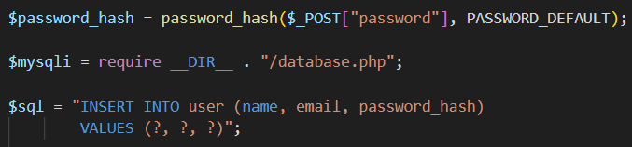

This is how it looks in the database table for the ‘a’ user:



The other method of providing security for the user, is making sure that the password users enter when registering an account is strong and secure enough.

For this project, the file that handles the possible scenarios of having a weak security is named ‘process.signup.php’. The main purpose of this code script is to make sure that the email and password are entered with user security in mind.

The first scenario is a user entering a password that does not fulfill the requirements of a strong password.

Test steps:

1) Navigate to the sign-up page

2) Fill in the required fields (Username, Email, Password, Repeat password)

3) In the email section, enter a password that is less than 8 characters, does not contain at least one letter and one number

4) Click Submit

Expected results:

1) The user receives error messages for each scenario of inputting a nonvalid password.

Even if only one of the above conditions is not fulfilled, the user cannot continue further with the sign-up process.

The aim of this testing is to make sure that the password entered is strong and secure. In this way, the user can feel much safer while navigating through the website.

3.15 Coding and visualization

Below I have attached some screenshots of the visual studio scripts and the website interface. I have included the most important ones that make the key features of my website.

Firstly, I have displayed the interface of the input forms in my website and their respective data models for each. The first screenshoot is the interface of the sign up form where users register for the first time as a user in this platform. The second one contains some testing data saved in the phpmyadmin database while being sure that the password does not appear as it was written in the input box by the user.

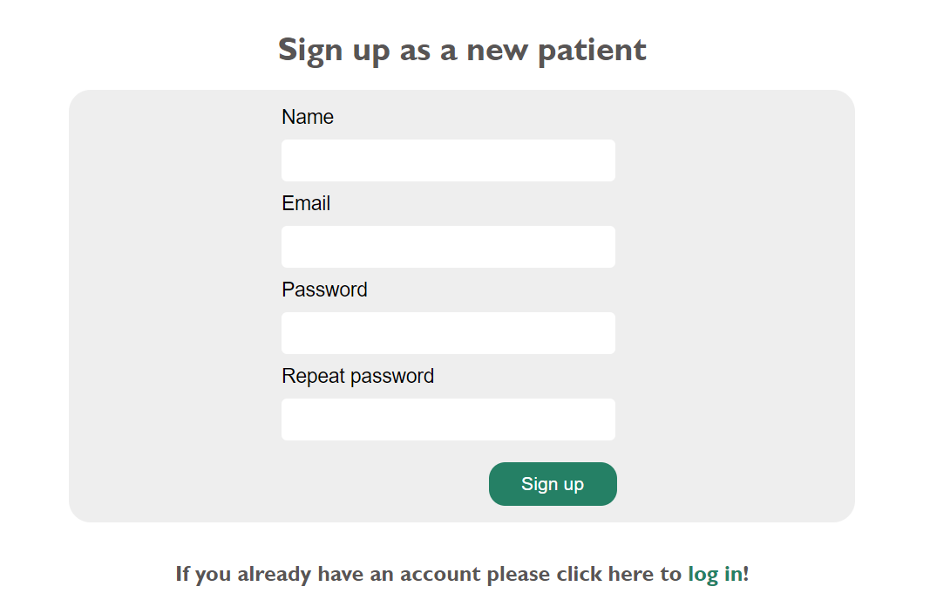

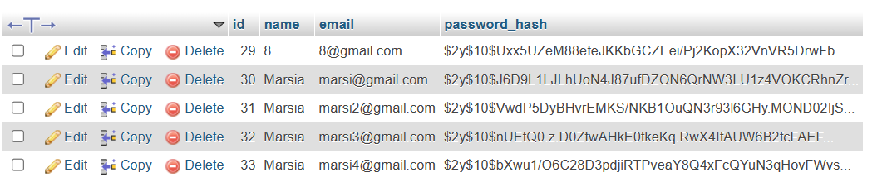

The following photo shows the login interface and the required fields to be completed in order to continue. The user can access this form by first signing up, or by clicking log in in the ‘sign up’ form if they already have an account in the system. This form is directly connected to the phpmyadmin database in order to check whether the user has already signed up and if yes does the password match the email entered.

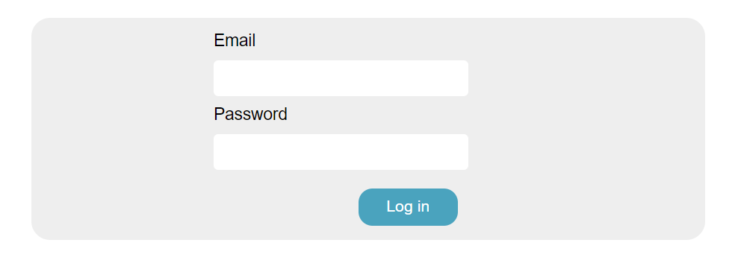

The code below handels the checking process whether the email entered in the input box is already a record in the database. Then by using the json method, the data gets transmitted between the server and the web application.

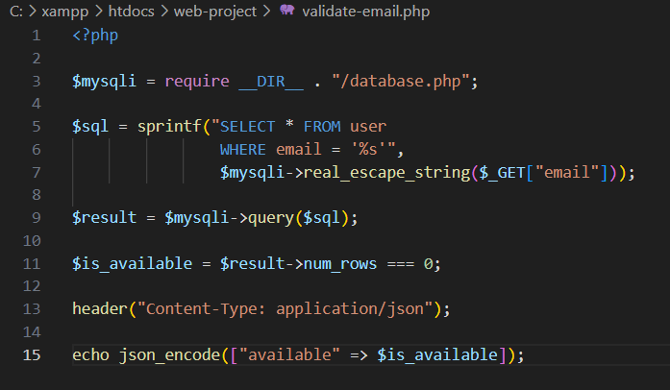

The reason why users need to create their online accounts and reuse them often, is because the information displayed for each of them in particular. Below I have attached some screenshots of two of the results after signing up and login in.

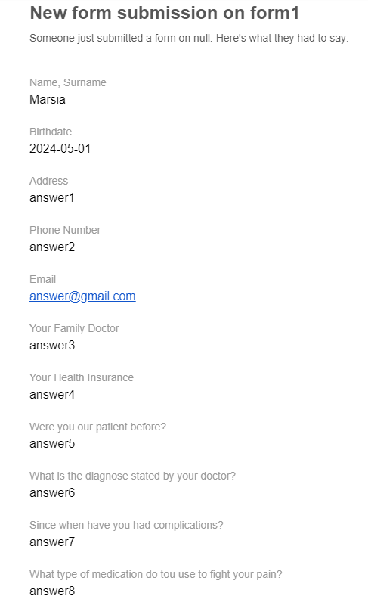

The form above shows the answers every user in particular writes in the tabular form. By using FormSpree, the answers come automatically in the email address so the staff can further analyze them and come up with the best treatment for the patients.

Below I have attached one example of how the appointment schedule looks like when a user reaches it after logging in. It is opened as a pdf file where all the necessary data for the appointments are written.

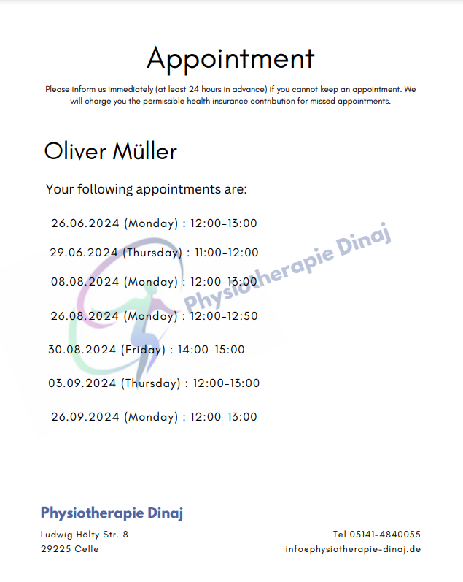

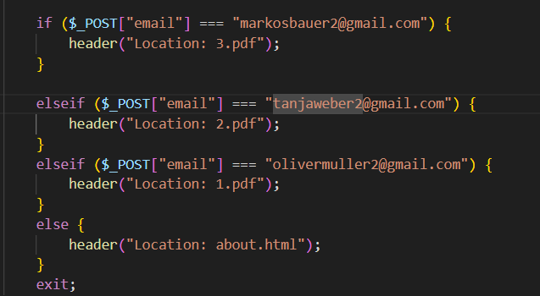

As the code above shows, I have assigned for three emails their respective pdf format appointment schedule. This code is part of the login.php file and it directs a pdf file when a patient logs in just for demonstrating purposes.

The following figures show another way of saving data for the staff to see later on. This time, I am showing the form a user needs to fill if they have more questions about the way this clinic works. All the fields displayed must be completed and after that they need to be submitted. The interface the user sees looks like this:

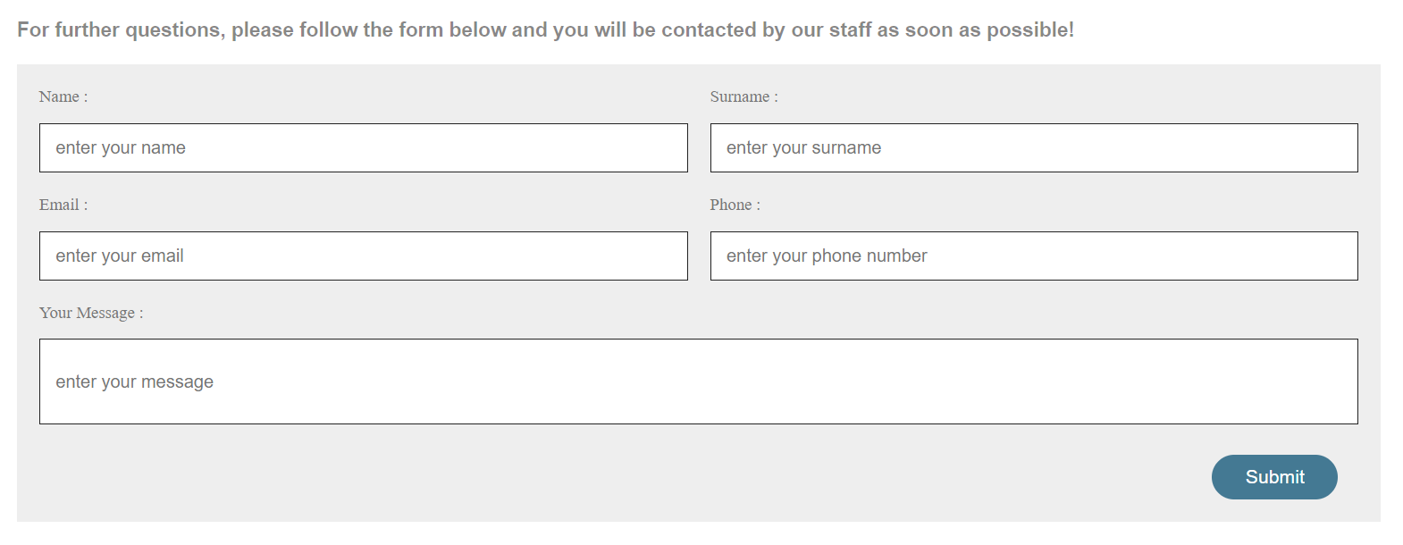

As mentioned in the previous pages, the data from this form are saved in a Spreadsheet file named ‘Contact us’. Every time a user clicks submit, that data is automatically saved as a new record in the below table.

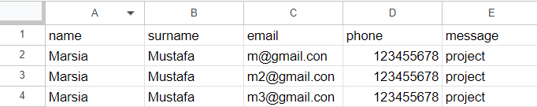

The code below shows some of the main lines that handle this submission and data saving.

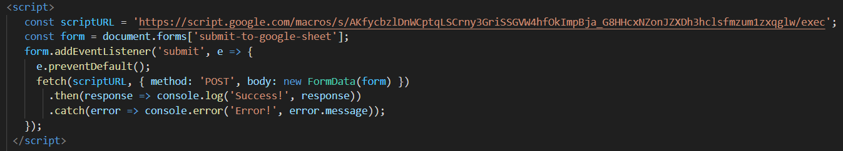

Below I have displayed a screenshot of the interface of the weather app using API key. The design is pretty simple and straightforward where the user only has to input the city they want to gather weather data. The data shown in the card below are taken from a weather website that contains real time and updated information.

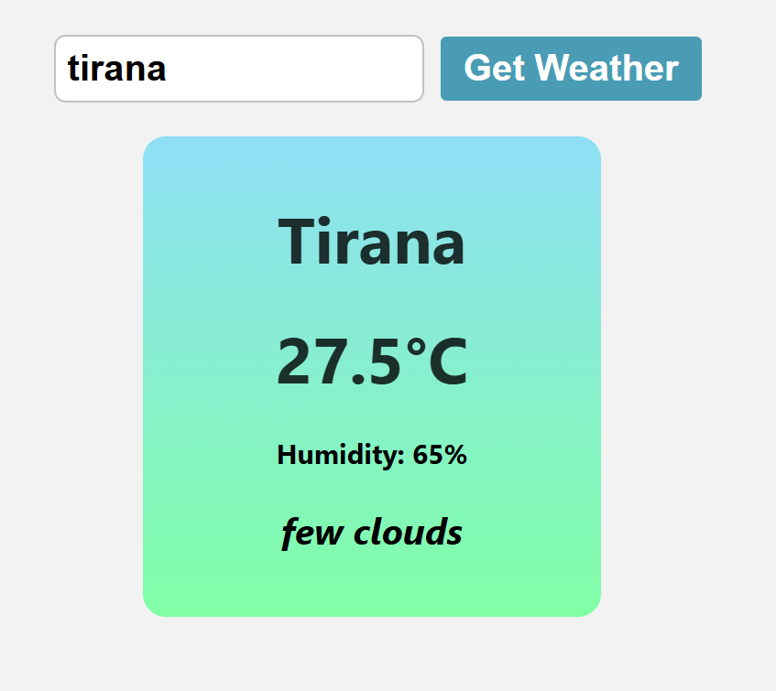

The code lines below show the main variables that make the connection with the weather website happen. These are part of a javascript file named script2.js where all the script code needed for this application are written there.





**4. CONCLUSION**

The final product of this project tends to help the ‘Physiotherapie Dinaj’ clinic grow and elevate its relationships with the patients. While focusing more on the visuals and designing elements, data saving processes and safe navigation, I think that this website has fulfilled its aim and hopefully the clinics aim too. I have tried to use various knowledge and researches so the website fulfills the user requirements that were set in the beginning. The website contains all the information needed sectioned and organized in a logical and easy way to follow. Overall, this project helped me a lot with putting in practice everything I have learned throughout my academic year and also mastering skills and filling gaps. It was challenging yet really helpful and interesting.

**5. REFERENCES**

[1] (Priyanka Surendran, 2012). Technology Acceptance Model: A Survey of Literature file:///C:/Users/Perdorues/Downloads/admin,+11.pdf

[2] (Sakun Boon, 2019). Quality of health websites and their influence on perceived usefulness, trust and intention to use: an analysis from Thailand https://www.researchgate.net/publication/330407842_Quality_of_health_websites_and_their_influence_on_perceived_usefulness_trust_and_intention_to_use_an_analysis_from_Thailand

[3] (Guy Pare, 2015). Internet as a Source of Health Information and its Perceived Influence on Personal Empowerment https://www.researchgate.net/publication/220168730_Internet_as_a_Source_of_Health_Information_and_its_Perceived_Influence_on_Personal_Empowerment

[4] (Juliet Jones, 2021). How a Website Can Help a Medical Clinic https://prable.org/blog/medical-website/

[5] (Healthsite). Top 5 Ways A Great Website Can Help Your Medical Business https://www.healthsite.com.au/top-5-ways-a-great-website-can-help-your-medical-business/

[6] (Cooper Adwin, 2023). How to Select the Best Fonts for a Header

<https://designerly.com/how-to-select-the-best-fonts-for-headers/?utm_source=rss&utm_medium=rss&utm_campaign=how-to-select-the-best-fonts-for-headers>

[7] (Irfan F.). The 20 Best HTML Fonts to Use in 2024

<https://www.hostinger.in/tutorials/best-html-web-fonts>